Online diary: 3/10/2020

The premise of the game was to implement the skills preferred by employers into a playable game which was built to house 3 teams of 2 at max and at minimum 2 teams of 1. This game focused on the core skills an employer would ideally look for within a potential candidate and looks to bring forward those skills within the player as many would be required to win the game.

The rules of the game are designed to test the levels of your employability skills, force you to think outside the box and make you think 2 moves ahead of the game. With the objective of the game to collect the most points with your teammate, this objective can only be completed through collaboration with your teammate, thus promoting the use of teamwork.

Each team selects an employer card which labels exactly what skills you need, highlighting what an employer looks for within a potential candidate, which was carefully researched through different employers’ expectations by looking up different job roles through different application websites.

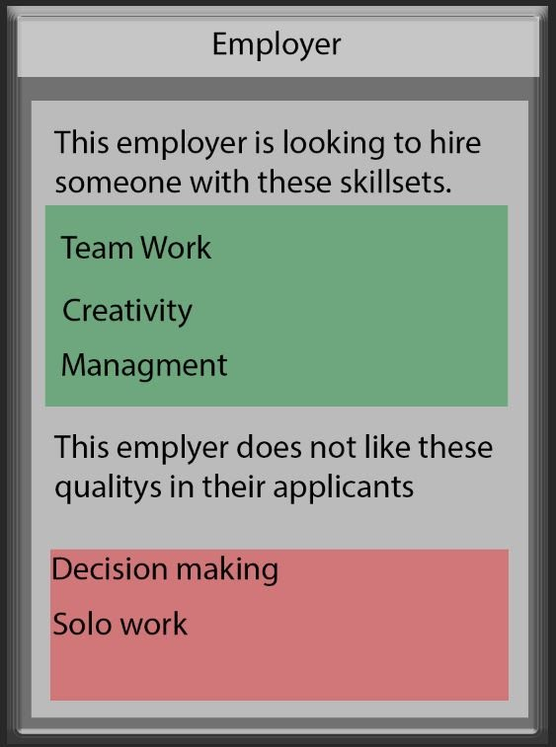

These are the skills that this specific employer would not find useful for a job within the game which would actually hinder the players progress.

These are the skills that this specific employer would find useful for a job within the game.

Following on from that, the players from each team will take turns to draw and play attribute cards that add points and stars onto different attributes to help you win the game.

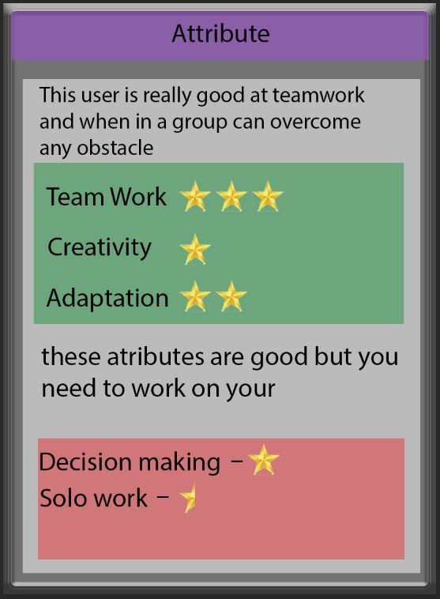

These are the how valuable or invaluable the attributes are to these different employers. These will help you gain different points and stars to help you win the game.

These are the attributes that are of no value to the employers within the game.

These are the attributes that are usually valued by an employer within the game.

These stars add onto your employers’ card and after reaching 5 stars for each category listed on the card. Whilst the opposing team could be working towards the same goal, they will attempt to hinder you by trading, stealing and discarding your cards. Not only does this teach you to build up the employable skills within yourself, but it also allows you to work up that competitive edge that the game requires.

Working within a team to design this game opened me up to a wider view of things, allowing me to open myself up to team collaboration when otherwise would have been quite shy within that aspect. There were many different ideas that were banded about, with a mixture of them being accepted to be stripped apart and re drafted into a whole new idea. Working with someone else also allowed me to work on my decision making, logical thinking and persuasion due to the fact that I had to persuade some of my team mates as to the usefulness of my idea as well as compromising with my fellow collaborators to take the idea from the majority vote.

Reflecting upon the experience team work and being able to compromise is the key skills that employers are looking for with a potential candidate, designing this game helped realise that these are the most important things that are required to be successful within an interview and future job.

The teamwork was very successful and co-operative however I would like to improve the overall communication of the team, whilst it was useful could have been a little more co-ordinated but was still overall a much more useful experience that expected.

Members: Connor Hadley, Sean Colbourne, Connor Winspur, Alyssa/Daniel Lamb